**Goal:**

Evaluate A/B testing results and decide which marketing strategy works the best.

For analysis of A/B test results we will use a confidence level of 99%.

**Target Metrics:**

The dataset provides three metrics:

* **Market size - this is a numerical measure of the size of a market 1-10**
* Age of store - this represents the number of years or another unit of time since a store was established.
* Sales in thousands - This directly quantifies the sales of a product or service, indicates business performance

Calculated Metrics:

* Number of sales – Number of Sales in each promotion when we combine all 4 weeks data.
* Average sales – The average sales when we combine all 4 weeks data.

Since the goal of the A/B test is to determine which marketing strategy works best, we will focus on financial metrics such as **'Sales in thousands'** and **‘Average sales’** metrics, as they directly reflect the monetary impact on each promotion.

**Calculations:**

The table contains the numbers necessary data to analyze the A/B test and reach a decision.

|  |  |  |  |
| --- | --- | --- | --- |
| Promotion | Number of sales | Average sales | Total sales |
| 1 | 43 | 232.4 | 9993.03 |
| 2 | 47 | 189.32 | 8897.93 |
| 3 | 47 | 221.46 | 10408.52 |

**Table 1**. Summary of Metrics from Fast Food Marketing Campaign A/B Test Results.

The table reveals a few key differences, with total sales for Promotion 2 being the smallest. This suggests that promotion 2 was likely not the most effective. On the other hand, Promotion 1 stands out as the most profitable, evidenced by its highest average sales. Interestingly, despite its success, Promotion 1 was implemented in four fewer restaurants compared to the others. Unfortunately, we cannot say why this has happened. However, it's important to note that we will further evaluate their significance.

In this analysis, we have computed key statistical measures for both "Average Sales" and "Sales in Thousands" across different promotional campaigns. These statistics help us understand the central tendency and variability of sales performance, which are critical for evaluating the effectiveness of the promotions and for making informed business decisions. These are the results:

**Average Sales**

* **Mean:** 214.39
* **Variance:** 501.42
* **Standard Deviation:** 22.39

Mean: The mean average sales across the campaigns is 214.39. This value represents the central point around which the sales data tends to cluster.

Variance: The variance of 501.42 indicates the degree of spread in the average sales data. This suggests that while the sales values fluctuate around the mean, the overall dispersion is moderate.

Standard Deviation: The standard deviation of 22.39 provides a measure of the average deviation of the sales figures from the mean. This further illustrates the consistency in sales performance, showing that most sales figures lie within a 22.39 range of the mean.

**Sales in Thousands**

* **Mean:** 9766.49
* **Variance:** 608,959.68
* **Standard Deviation:** 780.36

Mean: The mean total sales across the campaigns is 9,766.49 thousand. This indicates the average total revenue generated per promotion.

Variance: The variance of 608,959.68 is significantly higher compared to the average sales variance, highlighting a much greater variability in total sales figures. This suggests that total revenue can vary widely between different promotional campaigns.

Standard Deviation: The standard deviation of 780.36 reflects the average amount by which total sales deviate from the mean. The higher standard deviation, relative to average sales, indicates that total sales are more volatile and less predictable across different promotions.

The Between-Group Variance:

SSB = 43*(232.4−214.39)2 + 47*(189.32−214.39)2 + 47*(221.46−214.39)2 = 45796.55

The SSB of 45,903.2 tells us that there is a substantial difference between the average sales of the three promotional campaigns. This large value suggests that the different promotions have had varying impacts on sales, which might be enough to reject the null hypothesis that there is no difference between the campaigns.

The Within-Group Variance:

SSW = 143111.19 + 193191.51 + 188584.38 = 524887.0753

Promotion 1 = 143111.19

Promotion 2 = 193191.51

Promotion 3 = 188584.38

**Hypothesis:**

H0: There is no significant difference in the effectiveness of the three marketing campaigns on weekly sales; any observed differences are due to random variation.

H1: At least one of the three marketing campaigns has a significantly different effect on weekly sales.

ANOVA (Analysis of Variance) Test was selected for this as it is particularly useful in finance and data analytics for its ability to efficiently compare multiple groups and determine whether observed differences are statistically significant.

Following this, a 2-Sample T-Test was employed to compare the means of two specific groups. This test helps to determine whether the observed difference between the two groups is statistically significant. If the p-value from the T-Test is below the predetermined significance level (0.01), we reject the null hypothesis (H0), which posits that there is no significant difference between the groups

**ANOVA test:**

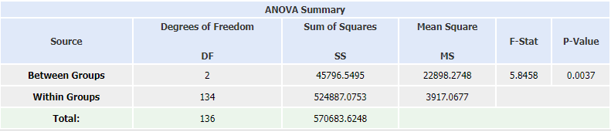

After doing the calculations we get that the p = 0.0037 which is < 0.01, therefore we reject the null hypothesis and state that At least one of the three marketing campaigns has a significantly different effect on weekly sales.

**Sample T-Test**

H0: μP1 = μP3

H1: μP1 ≠ μP3

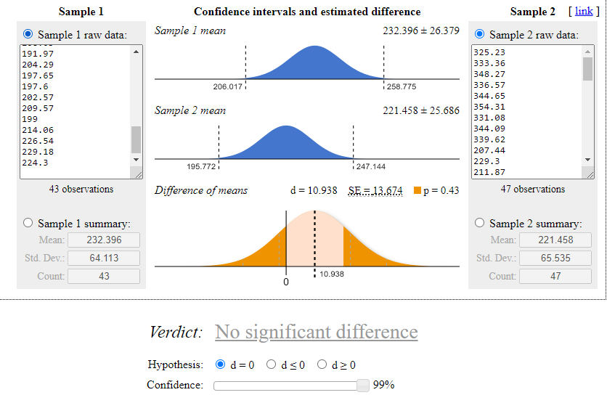

As the p value is >0.1 we cannot reject the null hypothesis and we can say that Promotion 1 and 3 has no significant difference.

H0: μP1 = μP2

H1: μP1 ≠ μP2

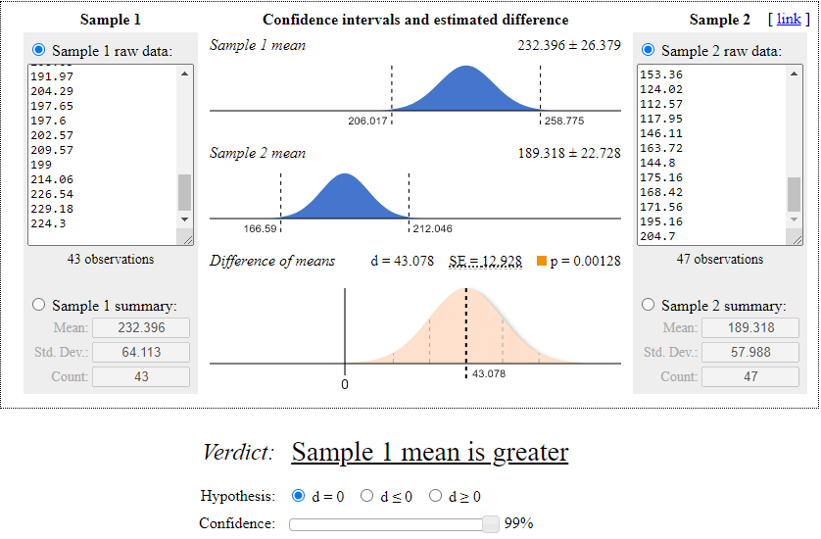

As the p value is <0.1 we reject the null hypothesis and we can say that Promotion 1 and 2 has a significant difference.

H0: μP3 = μP2

H1: μP3 ≠ μP2

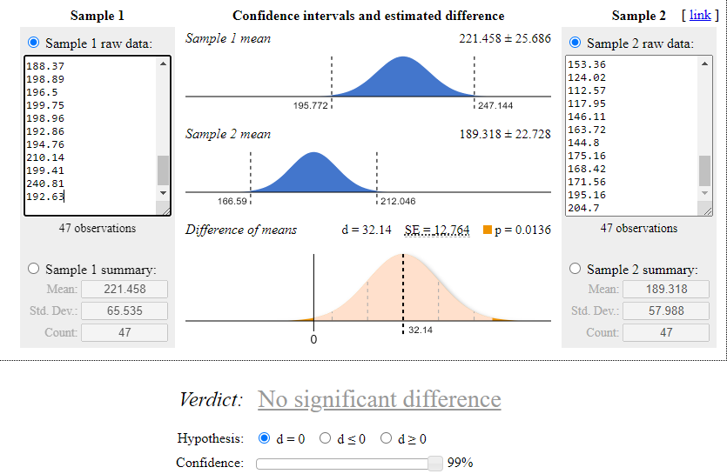

As the p value is >0.1 we cannot reject the null hypothesis and we can say that Promotion 3 and 2 has no significant difference.

To conclude, the statistical analysis indicates that there is no significant difference between Promotion 1 and Promotion 3, as well as between Promotion 3 and Promotion 2, given that their p-values are >0.1. However, there is a significant difference between Promotion 1 and Promotion 2, as evidenced by the p-value being <0.1. It is worth noting that the p-value for the comparison between Promotion 3 and Promotion 2 is close to the significance threshold. This suggests that with a larger dataset or further analysis, there might be enough evidence to detect a significant difference. However, based on the current data, we cannot definitively conclude that such a difference exists.

**Recomendations:**

After thorough analysis of an SQL table and several statistical tests, it is evident that Promotion 2 generates significantly less revenue compared to the other two promotions. Although statistical tests indicate no significant difference between Promotion 2 and Promotion 3, the SQL data presents a contrasting picture. Regrettably, we lack information on the costs associated with these promotions. Moving forward, I recommend prioritizing Promotion 1 or Promotion 3, with a preference for Promotion 1.

**Appendix:**

**Query for table 1**

WITH sales AS (

  SELECT

    promotion,

    location_id,

    ROUND(SUM(sales_in_thousands), 2) AS total_sales

  FROM

    tc-da-1.turing_data_analytics.wa_marketing_campaign

  GROUP BY

    promotion, location_id

)

SELECT

  promotion,

  COUNT(*) AS num_locations,

  ROUND(AVG(total_sales), 2) AS average_sales,

  ROUND(SUM(total_sales), 2) AS total_sales

FROM

  sales

GROUP BY

  promotion;